Higher Education
Myerscough College Farrier Department of Science
MR 3126 BSc (Hons)Farriery Top up

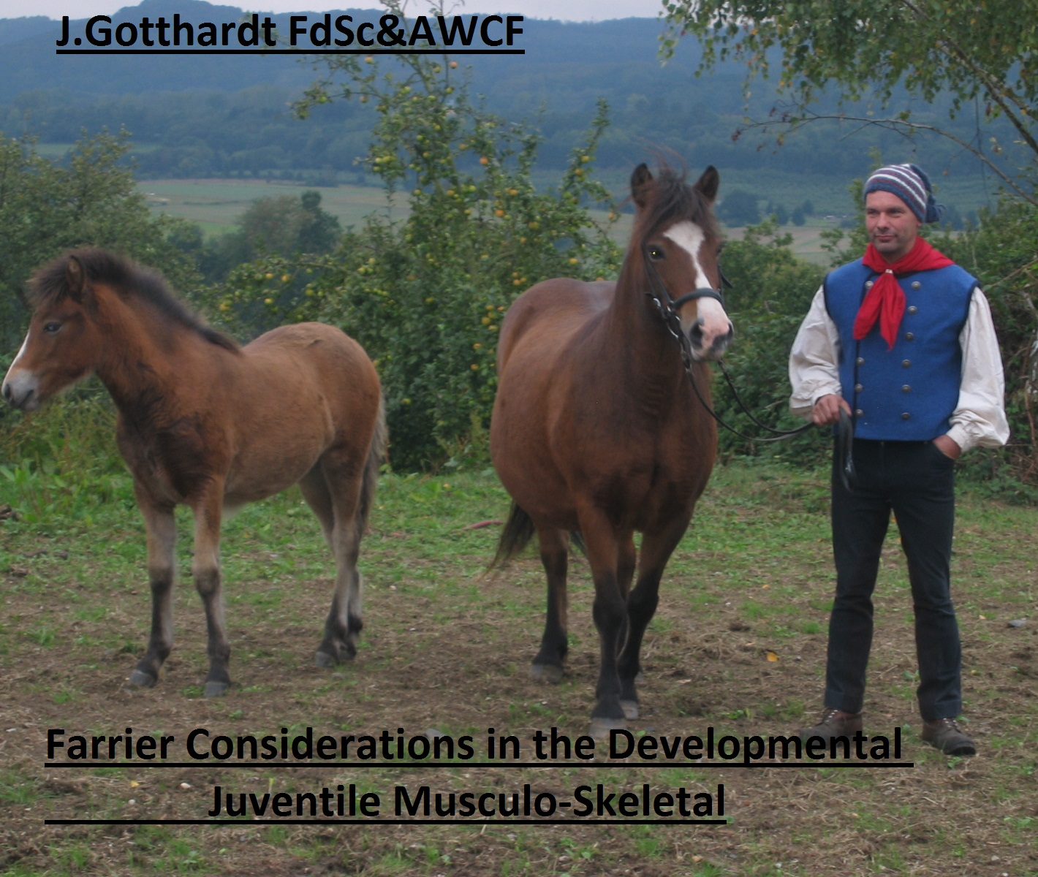

Assessment on conformation on 6 foals aged 1 -3 month
Name: Leija
Owner: XXXXXXX

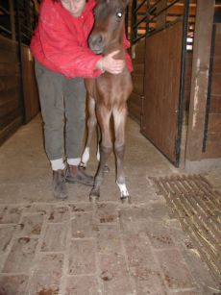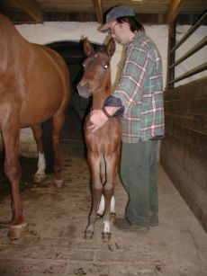
Date of birth 28 April 2009/ 1st pic. From 6th of May 2009
2ndpic. From 19th of May
German Leisure riding pony
Weight no data
Height no data

Description
Leija born on the 28 April 2009 with a angular limb deformities 2/5 carpus/valgus on the right front limb.
Owner and vet consult the farrier to help the foal
Foal and mother was rest in stable
A mild mediolateral balance show the right hoofcapsule
by observation on the 6 th of may and the right knee knocked the left. It was not occur that any hoofhorn medialpalmar was bending in on right foot. Hoofpastern angle was in a good alignment.
The intervention was just trim the bit on lateral hoof and with massive cotton wool and wrap stabilize the fetlock.
The same procedure was to do, so the instruction 8 days later,
and again 8 days later also
The movement of the foal should be control but increased
Daily with the help of a groom. 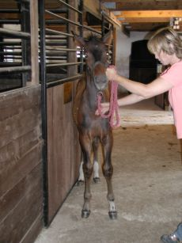

Name: Fjalla
Owner: XXXXXX
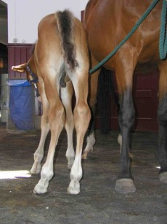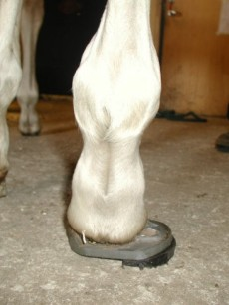

Date of birth 3 rd june 2006 / 1st pic. From 8th june 2006
2nd pic from 13 june 2006

Thorobred cross cob
Weight “underweight”
Height no measurement

Description
Fjalla born on the third of June in 2006 on field
ALD was seen on front and hind limbs.
No vet was introduce, just a farrier.
Foal could move, but was windswept on hind limbs.
It was occur that the foal needs some help on his right hind tarsus to stabilize the jointmovement. The little foot rotated inwards with the toe when weight was bearing. The lateral bulb was weight bearing the complete in the second stance phase.
A dallmer dalric was modifity to glue on this hind foot four the next few days together with foal-starter supplement fluid.
Foal and mother was separate on field, day and night so they could move how they want.
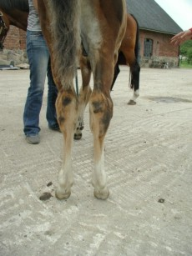 After 10 days we remove the shoe and use for another 10 days superfast as a extension. The pic 3 show the same foal aged 4 month.
Name: Big Boy
Owner:XXXXXXXX
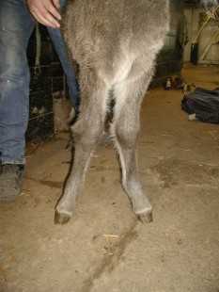
Date of Birth 02.Feb 2006 / pic from 5 th Feb 2006

Icelandic breed
Weight “underweight”
Height remained too small

Description
Big Boy born on the 5th of Feb. in 2007
One month too early after a malaise(colic) her young mother
ALD like windswept on hinds and valgus 1/3 on both fronts
The local vet and farrier was involved as a competent team working together with the stud personal.
The body- weight had no significant influence in the further limb deformities and changes in foot shape.
But the combination of pushing intravenous and glue on some helping shoes like dalmer” first foal” smallest section with a medial extension self made was really helpfully and quick and with no big problem an both hooves applied.

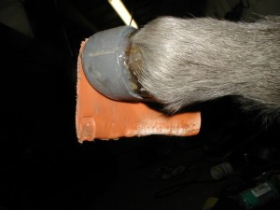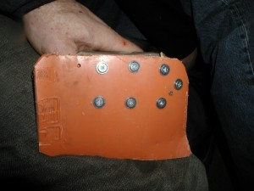
Stall rest was necessary because the wheather was so poor. The personal use the undercover riding manage for motion. Big Boy’s best friend was now the stall groom and the farrier. Twelve days later we pull off the glue shoes and let them off 4 days, than we spend him next bigger size for two weeks
Big Boy with his “Ski”
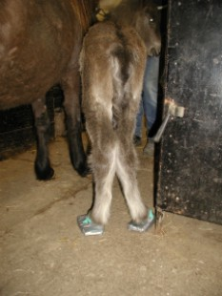 but it works well.
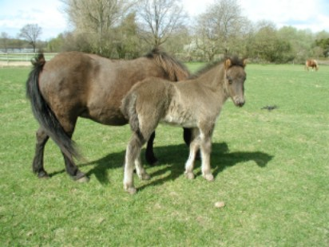
That’s Big Boy with mother in September 2007 7 month later after intervention in the early February days.

NameLarge Larry
Owner:XXXXXXXX

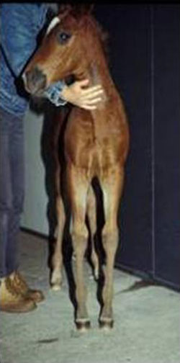
Date of birth 16 th March 2008 pic. from 26 May 2008
Arabian cross breed
Weight well performed
Height not measured but a lot growth

Description
LargeLarry was born with no problems 16 th March 2008
All lfour limbs was straight and show no angular limb deformities. LL grows quickly. Limb length and body weight as well. In the begin of May the staff occur that both front limbs turn from felock in and call the farrier to assess these early signs of varus ALD at the felock 4/5. The solar plane of the foot show a asymmetry and a mediolateral inbalance as well The lateral heel pushed to proximal displacement Also a rotational displacement of the toe was occur . It should be trim the high heels down and off the medial flare from both hooves.
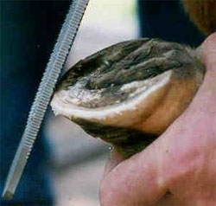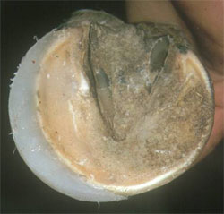
The instruction for the staff was that this procedure will be done frequently every two weeks.
Day and night needs to be that the foal could be free in field and or paddock. And Foal supplement is to reduce.

Name: Tom Tortilas
Owner: national Stud West-Germany

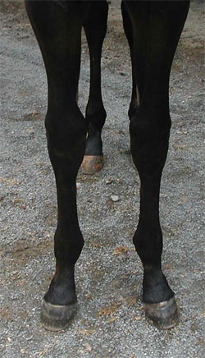
Date of birth 28 Feb 2009 pic. from 17 March 2009
Breed : German Warmbood (for dressage)
Weight 125 kg
Height not identifity

Description
Tom Tortilas, was born 28 Feb. 2009 .
A mild fetock valgus is since day occurs from the stable manager. While this deviation is not reduce and will be affect later the whole horses quality and may be reduce the chance to sell the horse and have some effects on performance and sound, the management consult a competent farrier to applies
Shoes or trim the hooves quickly.
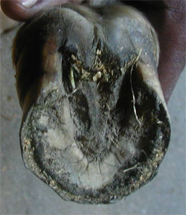
The observations identify an overload medial, what pushed upwards the heel with bulbs. The shape have change to asymmetry and mediolateral imbalance. Dynamically the foal was also assess on straight line in walk and trot. The farrier note changes in gait due to a mild lameness in trot.
A management plan include foot trimming protocol was create by the surgical farrier due to soundness of the juvenile equine.
That affect the muscular Skeletal system otherwise further posture change are occurred.
The foot were trimmed down the overgrowth 90° to the longitude axis and basic mediolateral balance.
This job needs to be done twice per month
The stud farriers was listen and watching the instructions and have done the job in the following months really good.
By the autumn auction the stud manager could sell the horse with nice straight limbs.

Name: Lucky Looser
Owner: XXXXXXX
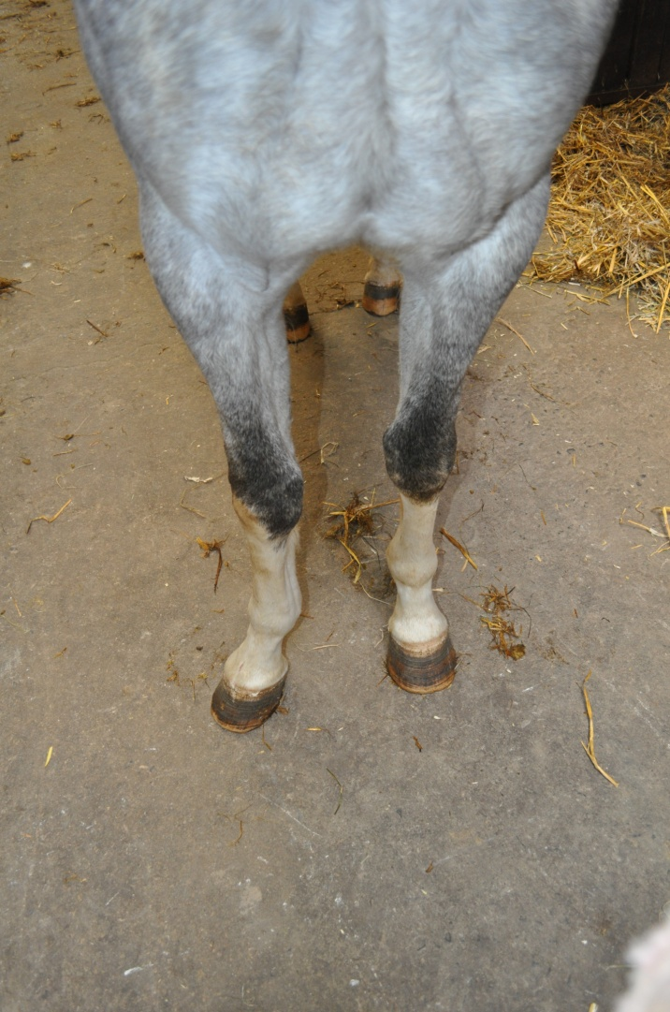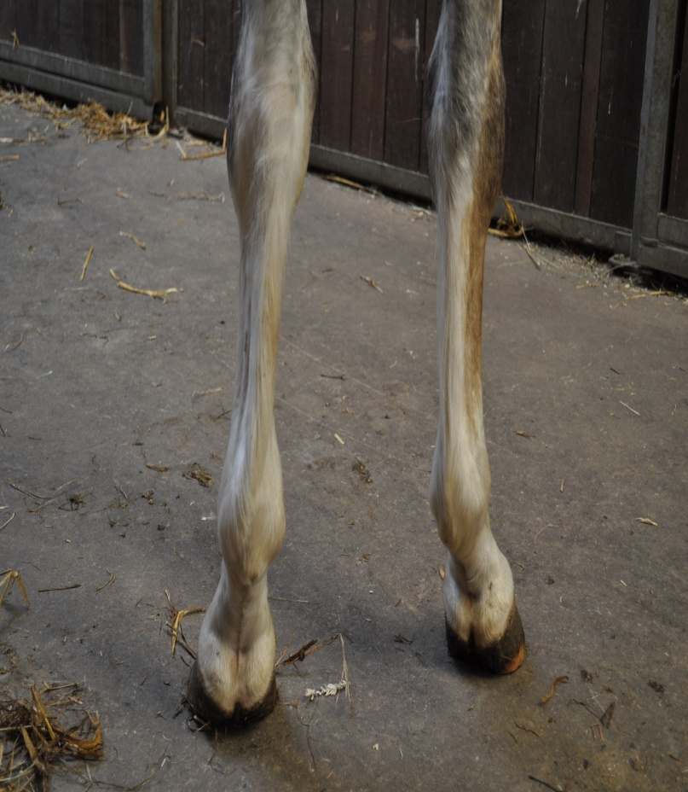
Date of birth Summer 2008/ pic. from 16April 2011
Breed : Holsteiner (Show jumping)
Weight: no data
Height : no data

Description
Lucky Looser was born in Summer 2008
With the age of three month the author an two other professional farriers observe this foal on a field in local area. The stud manager would like a prognosis how the hoses may be develop.
The oldes farrier state. That this foal show many clinical signs due to acquiered contracture of the distal interphalangeal joint.
It was to see that the foot
- growth faster at the heels than toe
- broken forward hoof pastern angle
- the toe angle was greater than 70°
- lameness in walk and trot on hard surface
- changes to an abnormally gait
- concave dorsal wall and
deep lateral sulci at heels

Treatment statement

Perfect management should be necessary, a section of carpal head of the deep digital flexor tendon (inferior check ligament) and very often a rasping down the high heels , or shoeing with anything what bring the foot in place where it should be norma l trimming should be done and repeated every second weeks,particularly when a toe extension has been applied. The heel trimming should be done and repeated every second weeks.
All this will depends on releasing tension in the deep flexor tendon and the weight of the foal will result in correct foot placement provided the foot shape will allow this.
Unfortunately the owner and breeder was not follow any instruction may be depend on his spare money and would like to see how the foal develop in time.
Have a lock to the adult horse 2011

.

